Item Title: Award Construction Contract in the Amount of $562,500 for the Wake County Board of Elections Storage Mezzanine

Specific Action Requested:
That the Board of Commissioners:

- Awards a construction contract to Scotia Construction, Inc. in the amount of $562,500.00 for the Wake County Board of Elections Storage Mezzanine; and

- Authorizes the County Manager to execute this contract subject to terms and conditions acceptable to the County Attorney.

Item Summary:

Purpose: NC State Statutes require the Board of Commissioners to award all publicly bid construction contracts on projects $500,000 and greater.

Background: The Wake County Board of Elections building contains a conditioned warehouse space that is used for statutory records retention, storage of voting equipment and staging of precinct-level elections supplies. Due to the ongoing growth of Wake County and updates to statutory guidelines, there is a continuous increase in the supplies and equipment required to conduct elections and associated records retention. The construction of a storage mezzanine will create additional storage capacity within the secured and conditioned warehouse without the need to purchase or lease additional storage space. The mezzanine will allow flexible space for staging supplies below and it increases the logistical footprint to allow for future growth.

Strategic Plan: This action supports routine County business.

Fiscal Impact: This project is funded in the County Buildings Element of the County Capital Improvement Program. The contract award is within the appropriated budget and no additional funds are required.

Additional Information:

In 2019, the Board of Elections relocated from the Waverly Akins Office Building to a 70,040 square foot facility located at 1200 N New Hope Road, Raleigh, NC, under a 15-year lease, with options to extend the term in the future. The lease was structured so that tenant improvements would be completed by Wake County. This building has been renovated in phases, including conditioning a large portion of the existing warehouse space.
In January 2024, the County’s design consultant completed a study of storage options for the Board of Elections. Their report compiled findings based on input from the Board of Elections staff, a tour of the building warehouse spaces, evaluation of code requirements, and expertise from subconsultant engineers on structural, electrical, mechanical, and fire protection considerations. Their report concluded that a new storage mezzanine would meet the requirements outlined by the Board of Elections staff to maintain flexible open staging space within the secured conditioned warehouse while expanding the footprint for records retention and other storage needs. The report outlined code limitations, scope requirements, budget, and schedule assumptions for two mezzanine options: pre-engineered and structural steel. Wake County staff authorized the design consultant to move forward with design of the structural steel mezzanine option. An isometric drawing of the new mezzanine and equipment lift is copied below:

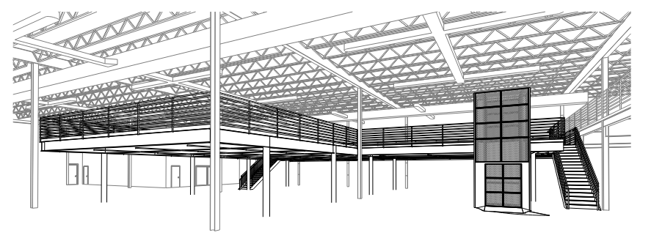
On December 18, 2024, bid proposals for the Board of Elections Storage Mezzanine were received from eleven (11) licensed contractors in accordance with North Carolina General Statutes. A bid tabulation is attached for review. The contract award consists of a base bid of $559,000.00, and acceptance of one (1) alternate at an additional cost of $3,500.00. The alternate bid is as follows:

Alternate #1: Electrical Receptacles on Mezzanine

Staff recommends awarding the construction contract to the lowest responsive and responsible bidder, Scotia Construction, Inc of Cary, North Carolina, in the amount of $562,500.00. It is anticipated that a Notice to Proceed will be issued in January 2025, with on-site work scheduled to begin no later than June 2025. Construction is expected to be substantially complete in August 2025. The Board of Elections will continue its operations without interruption throughout the project.

Attachments:
- Project Cost Summary
- Bid Tab

