Item Title: WCPSS Request for the Sale of Surplus Property Adjacent to Wendell Elementary School

Specific Action Requested:
That the Board of Commissioners approves or declines the Wake County Board of Education’s offer of an identified surplus property tract at fair market value pursuant to N.C.G.S. §115C-518.

Item Summary:

Purpose: State law requires that, when a Board of Education has surplus property, the County Board of Commissioners must be given the first opportunity to obtain the property at fair market value (N.C.G.S. §115C-518). The Wake County Board of Education has declared a small parcel remnant in Eastern Wake County as surplus, prompting this action item for the Board of Commissioners.

Background: The Wake County Board of Education (“WCBOE”) owns a 0.18 acre parcel in the Town of Wendell, adjacent to Wendell Elementary school. The parcel fragment is separated from the main body of the elementary school site assemblage. Its limited size, shape, location and encroachment of Anderson Street prohibit cost effective school uses. The parcel is needed by the Town of Wendell (“Town”) to support its improvement of Anderson Street with street paving, as well as installation of curb, gutter, and sidewalks. Upon completion, the Town’s public road improvements will improve vehicular and pedestrian access to the school. The Town will, in turn, close the street separating two adjacent school properties, helping consolidate the school campus.

County staff recommend that the Board of Commissioners decline the opportunity to purchase this parcel remnant, enabling the Town of Wendell and School Board to continue their joint plans.

Strategic Plan: This action supports routine County operations.

Fiscal Impact: Should the Board of Commissioners choose to acquire the Subject Property at fair market value, the fiscal impact will include the price of the Subject Property and any attendant costs of the acquisition process and closing.

Should the Board of Commissioners decline to acquire the Subject Property at fair market value, the WCBOE can proceed with disposition of the surplus property pursuant to the statutory process.

Additional Information:

The Board of Education owns a parcel of land in Wendell which is located in the northeastern quadrant of the intersection of Anderson Street and Poplar Street (the “Subject Property”). The Subject Property is identified as having PIN 1784-62-2548 and includes approximately 0.18 acres. It was acquired in 1941 as part of an assemblage for location of Wendell Elementary School (“WES”). The Subject Property is separated from the balance of the WES assemblage by Anderson Street, which roadway encroaches onto the parcel. Its limited size, shape, location and encroachment of Anderson Street thereon prohibit cost effective school uses. The Board declared the Subject Property to be surplus at its meeting on January 7, 2025.

The Subject Property is needed by the Town to support its widening and improvement of Anderson Street with street paving, installation of curb and gutter and provision of sidewalks. Upon completion, the Town’s public road improvements will improve vehicular and pedestrian access to WES. The School Board and Town have begun discussions about a potential joint approach. The exchange sought from the Town is its closure and dedication to Board of the undeveloped section of a dedicated public right of way known as Baron Drive which separates two BOE-owned parcels of the WES assemblage. The resulting recombined parcel will support WES with provision of a larger tract with multiple road frontages that will provide opportunities for renovation design flexibility and improved traffic circulation.

Per N.C.G.S. §115C-518, the Board of Commissioners is afforded the first right to obtain the Subject property fair market value. Should the County decline interest in acquiring the Surplus Property, Board of Education’s discussions with the Town will continue forward with the proposed land exchange pursuant to in NCGS §160A-274.

GIS Site Maps:

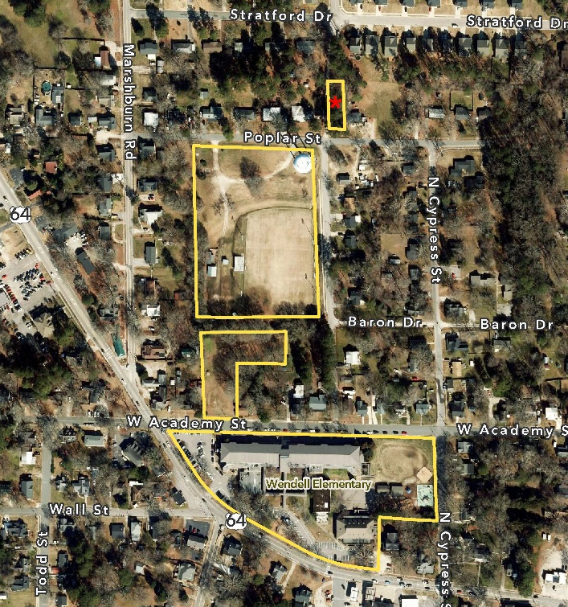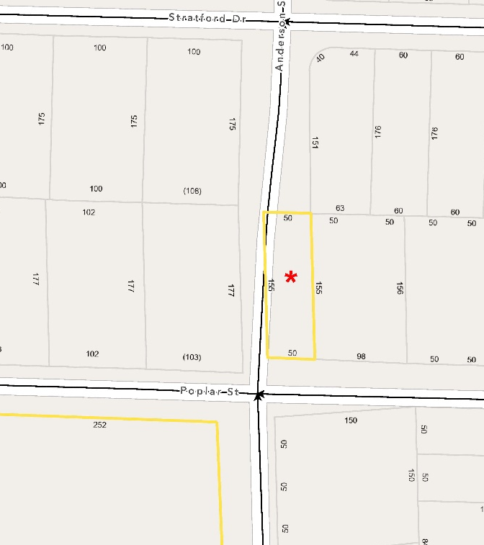
Wake County Staff Comments:

Notification has been provided to appropriate County staff with regards to the availability of the Surplus Property. Wake County staff has evaluated the information provided for the proposed disposition and has determined this property does not offer any reasonable opportunity for affordable housing use or any other County functions at this time.

Attachments:
- Presentation
- Board of Education Precis
- GIS Exhibits

